

A detailed report on industrial exports
and imports of industrial machinery and equipment in October 2017

Prepared by:
Ministry of Industry
Industrial Information Department

www.industry.gov.lb
Index

I. Introduction 3
II. Industrial exports in October 2017 4
1. Main exported products 4
2. Products with increased exports value 4
2.1. Base metals and articles of base metal 4
2.2. Prepared foodstuffs and tobacco 4
3. Products with decreased exports value 5
3.1. Products of the chemical industries 5
3.2. Pearls, precious or semi-precious stones, precious metals and articles thereof (Excluding unworked diamonds, silver and gold Ingots) 5
4. Main export markets 5
4.1. Main export markets by groups of countries 5
4.2. Main export markets by country 5
III. Imports of industrial machinery and equipment 6
1. Imported industrial machinery and equipment by country of origin 6
2. Imported industrial machinery and equipment by country of origin and industrial activity 6
IV. Appendix tables 7
V. Appendix charts 20

Introduction
The Industrial Information Department of the Ministry of Industry has prepared a detailed report on industrial exports and imports of industrial machinery and equipment for the month of October 2017.
It should be noted that the total value of industrial exports during the first ten months of the year 2017 amounted about 2 billion and 49 million US dollars compared to 2 billion and 117 million US dollars during the same period of the year 2016, and 2 billion and 505 million US dollars during the same period of the year 2015. Therefore we notice a decline of 3.2% compared to the year 2016, and a decline of 18.2% compared to the year 2015. (Tables 1 and 11(
It should also be noted that the monthly average of the Lebanese industrial exports during the first ten months of the year 2017 amounted about 204.9 million US dollars compared to 211.7 million US dollars during the year 2016, and 250.5 million US dollars during the year 2015.
On the other hand, the total value of imports of industrial machinery and equipment during the first ten months of the year 2017 amounted about 216.6 million US dollars compared to 197.7 million US dollars during the same period of the year 2016, and 205.9 million US dollars during the same period of the year 2015. Therefore, we notice an increase of 9.6% compared to the year 2016, and an increase of 5.2% compared to the year 2015. (Table 17)

Industrial exports in October 2017
The total value of industrial exports in October 2017 amounted to nearly 226.7 million US dollars, compared to 220 million US dollars in October 2016, and 255.3 million US dollars in October 2015, which is equivalent to an increase of 6.6 million US dollars, with the rate of 3% compared to year 2016, and a decline of 28.6 million US dollars with the rate of 11.2%, compared to year 2015. (Table 1, Chart 1)

Main exported products
Exports of prepared foodstuffs and tobacco came first in October 2017, with a total value of 46.9 million US dollars; Syria was on top of importers list of this product, with an import value of 8.6 million US dollars. Followed by exports of machinery and electrical equipment, with a total value of 43.8 million US dollars, Iraq was the largest importer of this product, with an import value of 7.1 million US dollars. Then products of the chemical industries, with a total value of 32.1 million US dollars, Iraq topped the importers list of this product, with an import value of 7.2 million US dollars, followed by base metals and articles of base metal, with a total value of 31.9 million US dollars. (For more details tables 2, 4, 6, 8, 10, 15, and 16)

Products with increased exports value
Statistics showed a significant increase in exports of the following products:

Base metals and articles of base metal
Exports of this product increased from 20.5 million US dollars in October 2016 to 31.9 million US dollars in October 2017 (Table 2 and Chart 2). The exports of this product mainly increased to Turkey, Spain, Republic of Korea and China which led to an increase in the total value of about 11.5 million US dollars. (Tables 3 and 4)

Prepared foodstuffs and tobacco
Exports of this product increased from 40.4 million US dollars in October 2016 to 46.9 million US dollars in October 2017 (Table 2 and Chart 2). The exports of this product decreased to Turkey whereas it mainly increased to Egypt, Qatar which led to an increase of the total value of about 6.5 million US dollars. (Tables 5 and 6)

Products with decreased exports value
Statistics showed a significant decrease in exports of the following products:

Products of the chemical industries
Exports of this product decreased from 40.8 million US dollars in October 2016 to 32.1 million US dollars in October 2017 (Table 2 and Chart 2). The exports of this product increased to Iraq whereas it mainly decreased to Turkey, Uruguay, and Ivory Coast which led to a fall of the total value of about 8.7 million US dollars. (Tables 7 and 8)

Pearls, precious or semi-precious stones, precious metals and articles thereof (Excluding unworked diamonds, silver and gold Ingots)
Exports of this product decreased from 14 million US dollars in October 2016 to 9.1 million US dollars in October 2017 (Table 2 and Chart 2). The exports of this product increased to Switzerland whereas it mainly decreased to United Kingdom and United Arab Emirates which led to a fall of the total value of about 4.9 million US dollars. (Tables 9 and 10)

Main export markets

Main export markets by groups of countries
Arab countries were the main market for Lebanese industrial exports in October 2017, with a total export value of 124.6 million US dollars, with a rate of 55% of the total export value. European countries Were the second largest export markets with a rate of 16.4% of the total export value. Followed by, Non-arab African countries with a rate of 12.1% of the total export value, and, the Non-arab Asian countries with a rate of 9.3% of the total export value. The main products exported to Arab countries are: prepared foodstuffs and tobacco with the total value of 29.9 million US dollars, machinery and electrical equipment with the total value of 24.9 million US dollars, and the products of the chemical industries with the total value of 23.7 million US dollars. (Table 12)

Main export markets by country
Among countries importing Lebanese industrial products, Syria ranked first with a total value of 22.8 million US dollars, with a rate of 10.1% of the total export value. Iraq came second with a total value of 19.6 million US dollars with a rate of 8.7% of the total export value. Followed by, Saudi Arabia with a total value of 18.8 million US dollars with a rate of 8.3% of the total exports value. (Table 13)
During this month, Lebanese products were exported to 45 European countries, 40 Non-arab African countries, 27 American countries, 27 Non-arab Asian countries, 19 Arab countries, and 8 Oceanic countries. Countries that imported Lebanese goods by over 1 million US dollars are as following: 13 Arab countries, 11 European countries, 9 Non-arab African countries, 4 Non-arab Asian countries, and 2 American countries, and 1 Oceanic country. (Table 14, Charts 3 and 4)

Imports of industrial machinery and equipment
The total import value of industrial machinery and equipment in October 2017 reached about 22.4 million US dollars compared to 14.5 million US dollars during the same period in 2016, and 16.5 million US dollars during the same period in 2015, an increase by 54.2% compared to year 2016, and an increase of 35.5% compared to year 2015. (Tables 17 and 18 and Chart 5)

Imported industrial machinery and equipment by country of origin
China ranked first on the list of countries exporting industrial machinery and equipment to Lebanon, with a total value amounting to about 5.5 million US dollars, followed by Romania, with a total value of 4.6 million US dollars, and Italy, with a total value of 2.6 million US dollars. (Table 18)

Imported industrial machinery and equipment by country of origin and industrial activity
In October 2017, imports of machines for food industry, ranked first, with a total value of 3.2 million US dollars, and China topped the list of countries exporting of this product to Lebanon with exports value of 929 thousand US dollars, followed by machines for rubber and plastics industry, with a total value of 1.5 million US dollars. China was the leading exporter of this product with an export value of 547 thousand US dollars. Followed by machines for paper and cardboard industry, with a total value of 1.2 million US dollars. (Table 19, Chart 6)

Appendix tables

Table 1: Industrial exports during Years 2015 – 2016 – 2017
Month | Year  2015 | Year  2016 | Year  2017 | Variation in %  2015/2017 | Variation in %  2016/2017
January | 243.2 | 199.5 | 175.9 | -27.7% | -11.8%
February | 237.5 | 222.8 | 196.8 | -17.1% | -11.7%
March | 246.5 | 211.6 | 223.9 | -9.2% | 5.8%
April | 240.2 | 231.1 | 210.4 | -12.4% | -8.9%
May | 280.6 | 210.6 | 205.9 | -26.6% | -2.3%
June | 292.1 | 225.3 | 199.0 | -31.9% | -11.7%
July | 233.5 | 178.8 | 215.7 | -7.6% | 20.7%
August | 233.4 | 232.9 | 227.0 | -2.8% | -2.5%
September | 242.5 | 184.3 | 167.6 | -30.9% | -9.0%
October | 255.3 | 220.0 | 226.7 | -11.2% | 3.0%
November | 219.9 | 193.7
December | 231.1 | 216.3
Total | 2,955.8 | 2,526.9 | 2,048.9
All above figures are in Millions of USD

Table 2: Comparison of industrial exports during October 2017 and October 2016
Section | Goods | October 2016 | October 2017 | Variation 2016/2017 | Variation in % 2016/2017
1 | Animal products | 0.35 | 0.43 | 0.08 | 22.5%
2 | Vegetable products | 4.00 | 4.76 | 0.76 | 19.0%
3 | Fats and edible fats and oils | 2.47 | 3.18 | 0.72 | 29.0%
4 | Prepared foodstuffs and tobacco | 40.35 | 46.86 | 6.51 | 16.1%
5 | Mineral products | 0.90 | 0.63 | -0.27 | -29.9%
6 | Products of the chemical industries | 40.75 | 32.10 | -8.65 | -21.2%
7 | Plastics and rubber and articles thereof | 14.05 | 17.27 | 3.22 | 22.9%
8 | Raw hides and skins, leather, furskins and articles thereof | 1.05 | 0.91 | -0.14 | -13.3%
9 | Wood and articles of wood | 0.89 | 1.01 | 0.12 | 13.1%
10 | Paper and paperboard and articles thereof | 11.35 | 11.45 | 0.10 | 0.9%
11 | Textiles and textile articles | 8.55 | 5.87 | -2.68 | -31.4%
12 | Footwear, headgear, prepared feather | 0.51 | 0.90 | 0.39 | 78.0%
13 | Articles of stone, plaster, cement; glass and glassware | 2.34 | 2.02 | -0.32 | -13.6%
14 | Pearls, precious or semi-precious stones, precious metals and articles thereof (Excluding unworked diamonds, silver and gold Ingots) | 13.98 | 9.08 | -4.90 | -35.1%
15 | Base metals and articles of base metal | 20.45 | 31.93 | 11.48 | 56.1%
16 | Machinery and electrical equipment | 46.93 | 43.76 | -3.17 | -6.7%
17 | Transport equipment | 2.54 | 3.72 | 1.18 | 46.7%
18 | Optical, measuring, medical, and musical instruments; clocks and watches | 1.31 | 2.22 | 0.91 | 69.2%
19 | Arms and ammunition | 0.00 | 0.00 | 0.00 | 0.0%
20 | Miscellaneous manufactured articles | 7.26 | 8.58 | 1.32 | 18.1%
 | Total | 220.04 | 226.69 | 6.64 | 3.0%
All above figures are in Millions of USD
Table 3: Exports of base metals and articles of base metal according to the main importing countries during October 2016
Export destination Country | Turkey | Republic of Korea | Bulgaria | Japan | Italy | Saudi Arabia | India | China
Value in thousands of USD | 4,739 | 3,203 | 1,066 | 1,023 | 901 | 782 | 713 | 700

Table 4: Exports of base metals and articles of base metal according to the main importing countries during October 2017
Export destination Country | Turkey | Republic of Korea | Spain | China | Ivory Coast | France | Saudi Arabia | Greece
Value in thousands of USD | 8,347 | 4,940 | 3,727 | 1,766 | 1,142 | 1,026 | 973 | 970

Table 5: Exports of prepared foodstuffs and tobacco according to the main importing countries during October 2016
Export destination Country | Syria | Saudi Arabia | Iraq | Turkey | United States Of America | Qatar | United Arab Emirates | Kuwait
Value in thousands of USD | 8,507 | 4,242 | 3,373 | 3,343 | 2,703 | 1,626 | 1,601 | 1,245

Table 6: Exports of prepared foodstuffs and tobacco according to the main importing countries during October 2017
Export destination Country | Syria | Saudi Arabia | Egypt | Qatar | United States Of America | Iraq | United Arab Emirates | Germany
Value in thousands of USD | 8,585 | 5,049 | 4,452 | 3,240 | 3,116 | 2,939 | 1,813 | 1,471

Table 7: Exports of products of the chemical industries according to the main importing countries during October 2016
Export destination Country | Turkey | Italy | United Arab Emirates | Uruguay | Iraq | Ivory Coast | Jordan | Saudi Arabia
Value in thousands of USD | 4,984 | 4,718 | 4,494 | 4,398 | 3,170 | 2,719 | 2,714 | 2,707

Table 8: Exports of products of the chemical industries according to the main importing countries during October 2017
Export destination Country | Iraq | United Arab Emirates | Italy | Jordan | Saudi Arabia | Syria | Kuwait | Greece
Value in thousands of USD | 7,185 | 5,492 | 4,100 | 2,734 | 2,468 | 1,518 | 1,482 | 788

Table 9: Exports of pearls, precious or semi-precious stones, precious metals and articles thereof (Excluding unworked diamonds, silver and gold Ingots) according to the main importing countries during October 2016
Export destination Country | United Arab Emirates | United Kingdom | United States Of America | Jordan | Saudi Arabia | Switzerland | Thailand | Oman
Value in thousands of USD | 5,522 | 3,239 | 1,768 | 836 | 834 | 496 | 469 | 324

Table 10: Exports of pearls, precious or semi-precious stones, precious metals and articles thereof (Excluding unworked diamonds, silver and gold Ingots) according to the main importing countries during October 2017
Export destination Country | United Arab Emirates | Switzerland | United States Of America | Belgium | Jordan | Hong Kong | France | Turkey
Value in thousands of USD | 3,664 | 2,049 | 1,259 | 594 | 454 | 382 | 190 | 159

Table 11: Industrial exports according to exported goods during year 2017

Table 12: Industrial exports according to exported goods and countries groups during October 2017
Goods | Arab Countries | European Countries | Oceanic Countries | Non-Arab Asian countries | American Countries | Non-Arab African countries | Other* | Total
Animal products | 334 | 1 |  |  | 29 | 65 |  | 429
Vegetable products | 1,991 | 1,399 | 25 | 282 | 426 | 634 |  | 4,758
Fats and edible fats and oils | 1,562 | 849 | 47 | 54 | 448 | 224 |  | 3,183
Prepared foodstuffs and tobacco | 29,915 | 7,041 | 797 | 681 | 4,943 | 2,868 | 618 | 46,862
Mineral products | 395 | 4 |  |  |  | 104 | 131 | 633
Products of the chemical industries | 23,659 | 6,422 | 147 | 208 | 442 | 1,116 | 103 | 32,096
Plastics and rubber and articles thereof | 11,856 | 1,854 | 9 | 444 | 564 | 2,322 | 221 | 17,270
Raw hides and skins, leather, furskins and articles thereof | 422 | 366 |  | 48 | 7 | 69 |  | 913
Wood and articles of wood | 744 | 18 | 1 |  | 9 | 235 |  | 1,006
Paper and paperboard and articles thereof | 7,647 | 1,020 | 5 | 512 | 106 | 2,085 | 75 | 11,450
Textiles and textile articles | 2,918 | 2,289 | 64 | 61 | 89 | 322 | 127 | 5,869
Footwear, headgear, prepared feather | 610 | 36 |  | 2 | 4 | 246 | 2 | 900
Articles of stone, plaster, cement; glass and glassware | 1,268 | 72 | 7 | 96 | 112 | 466 |  | 2,021
Pearls, precious or semi-precious stones, precious metals and articles thereof (Excluding unworked diamonds, silver and gold Ingots) | 4,286 | 2,935 |  | 564 | 1,276 | 15 | 3 | 9,079
Base metals and articles of base metal | 4,153 | 7,499 | 127 | 16,354 | 20 | 3,640 | 135 | 31,929
Machinery and electrical equipment | 24,934 | 3,812 | 131 | 1,814 | 2,273 | 8,740 | 2,057 | 43,761
Transport equipment | 530 | 603 |  |  | 61 | 2,530 |  | 3,725
Optical, measuring, medical, and musical instruments; clocks and watches | 1,455 | 524 |  | 12 | 219 | 11 | 2 | 2,223
Arms and ammunition |  |  |  |  |  |  |  | 0
Miscellaneous manufactured articles | 5,940 | 344 | 278 | 23 | 162 | 1,816 | 15 | 8,578
Total | 124,618 | 37,088 | 1,639 | 21,155 | 11,189 | 27,508 | 3,489 | 226,686
All the above figures are in thousands of US dollars.
* "other" Includes exported goods to the duty free market and those that are supplied to ships and aircraft.
Table 13: Distribution of the industrial exports according to the main importing countries during October 2017
Export destination Country | Syria | Iraq | Saudi Arabia | United Arab Emirates | Qatar | Turkey | Kuwait | United States Of America
Value in thousands of USD | 22,794 | 19,616 | 18,792 | 17,010 | 10,624 | 9,793 | 8,264 | 8,009

Export destination Country | Jordan | Egypt | France | Italy | Republic of Korea | Ivory Coast | Spain | Congo
Value in thousands of USD | 7,666 | 7,171 | 6,029 | 5,093 | 4,996 | 4,882 | 4,802 | 4,718

Export destination Country | Germany | Algeria | United Kingdom | Netherlands | Switzerland | Nigeria | Bahrain | Greece
Value in thousands of USD | 2,914 | 2,878 | 2,726 | 2,691 | 2,660 | 2,243 | 2,219 | 2,122

Table 14: Distribution of importing countries according to countries groups and the value of exports during October 2017
Exports Value  (in million USD) | Arab Countries | European Countries | Oceania Countries | Non-Arab Asian countries | American Countries | Non-Arab African countries | Total
]0-1[ | 6 | 34 | 7 | 23 | 25 | 31 | 126
[1-5[ | 5 | 9 | 1 | 3 | 1 | 9 | 28
[5-10[ | 3 | 2 |  | 1 | 1 |  | 7
[10-15[ | 1 |  |  |  |  |  | 1
More than 15 million USD | 4 |  |  |  |  |  | 4
Total | 19 | 45 | 8 | 27 | 27 | 40 | 166

Table 15: Distribution of the industrial exports according to product and to the main importing countries during October 2017

Animal products | Qatar | United Arab Emirates | Kuwait | United States Of America | Liberia | Senegal | Guinea | Gabon
Value in 1000 of USD | 235 | 45 | 39 | 18 | 12 | 9 | 8 | 7

Vegetable products | United Arab Emirates | Sweden | Qatar | Netherlands | Germany | Saudi Arabia | Turkey | Jordan
Value in 1000 of USD | 615 | 508 | 362 | 342 | 336 | 294 | 254 | 198

Fats and edible fats and oils | Netherlands | Iraq | United States Of America | Sudan | Portugal | Saudi Arabia | Qatar | Kuwait
Value in 1000 of USD | 420 | 393 | 341 | 255 | 229 | 217 | 210 | 163

Mineral products | Syria | Other | Angola | Jordan | Nigeria | Kuwait | Ivory Coast | Congo
Value in 1000 of USD | 330 | 130 | 43 | 34 | 17 | 15 | 15 | 10

Plastics and rubber and articles thereof | Syria | Saudi Arabia | Ivory Coast | Spain | Egypt | Iraq | United Arab Emirates | Qatar
Value in 1000 of USD | 6,730 | 1,670 | 942 | 689 | 681 | 593 | 447 | 446

Raw hides and skins, leather, furskins and articles thereof | Portugal | United Arab Emirates | Egypt | Kuwait | France | Italy | Qatar | Turkey
Value in 1000 of USD | 201 | 175 | 108 | 70 | 56 | 55 | 37 | 35

Wood and articles of wood | Syria | Jordan | Qatar | Seychelles | Saudi Arabia | Kuwait | Congo | Nigeria
Value in 1000 of USD | 217 | 213 | 147 | 109 | 60 | 45 | 39 | 37

Paper and paperboard and articles thereof | Algeria | Qatar | Saudi Arabia | Jordan | Syria | Morocco | United Arab Emirates | Egypt
Value in 1000 of USD | 1,413 | 964 | 954 | 824 | 660 | 472 | 456 | 434

Textiles and textile articles | France | Syria | United Arab Emirates | Italy | United Kingdom | Qatar | Kuwait | Tunisia
Value in 1000 of USD | 849 | 780 | 451 | 431 | 411 | 310 | 290 | 266

Table 15: (continued) Distribution of the industrial exports according to product and the main importing countries during October 2017
Footwear, headgear, prepared feather | Saudi Arabia | Liberia | Benin | United Arab Emirates | Qatar | Kuwait | Jordan | Morocco
Value in 1000 of USD | 404 | 144 | 84 | 82 | 46 | 23 | 18 | 17

Articles of stone, plaster, cement; glass and glassware | Qatar | United Arab Emirates | Kuwait | Congo | Saudi Arabia | Nigeria | United States Of America | Iran
Value in 1000 of USD | 370 | 308 | 211 | 191 | 150 | 146 | 110 | 94

Machinery and electrical equipment | Iraq | Kuwait | Saudi Arabia | Syria | United States Of America | United Arab Emirates | Qatar | Other
Value in 1000 of USD | 7,115 | 3,944 | 3,022 | 2,954 | 2,155 | 2,124 | 2,063 | 2,057

Transport equipment | Congo | United Kingdom | Ivory Coast | Syria | Iraq | United Arab Emirates | Sweden | France
Value in 1000 of USD | 2,198 | 257 | 149 | 133 | 111 | 103 | 87 | 82

Optical, measuring, medical, and musical instruments; clocks and watches | Bahrain | United Arab Emirates | France | United States Of America | Germany | Switzerland | Syria | Italy
Value in 1000 of USD | 1,109 | 265 | 257 | 205 | 159 | 64 | 51 | 28

Arms and ammunition
Value in 1000 of USD

Miscellaneous manufactured articles | Saudi Arabia | Qatar | Ivory Coast | United Arab Emirates | Jordan | Congo | Fiji | Kuwait
Value in 1000 of USD | 3,111 | 834 | 634 | 551 | 460 | 384 | 264 | 262

Table 16: Distribution of industrial exports, according to the main exported goods and main importing countries during October 2017

Table 17: Imports of industrial machinery and equipment during years 2015-2016-2017
Month | Year  2015 | Year  2016 | Year  2017 | Variation in %  2015/2017 | Variation in %  2016/2017
January | 20.5 | 25.3 | 21.0 | 2.4% | -17.1%
February | 22.3 | 17.3 | 10.7 | -52.1% | -38.3%
March | 20.5 | 25.1 | 20.2 | -1.3% | -19.4%
April | 19.1 | 22.8 | 18.0 | -5.8% | -20.9%
May | 28.0 | 20.5 | 23.1 | -17.5% | 12.3%
June | 23.7 | 20.0 | 22.2 | -6.2% | 10.9%
July | 20.1 | 16.8 | 21.8 | 8.5% | 29.9%
August | 21.3 | 19.0 | 27.0 | 26.9% | 42.1%
September | 13.8 | 16.2 | 30.1 | 117.5% | 85.4%
October | 16.5 | 14.5 | 22.4 | 35.5% | 54.2%
November | 18.9 | 20.0
December | 18.7 | 17.9
Total | 243.4 | 235.5 | 216.6
All above figures are in Millions of USD

Table 18: Imports of industrial equipment and machinery according to exporting country for the year 2017
Table 19: Imports of industrial equipment and machinery according to industrial activity and country during October 2017

Appendix charts
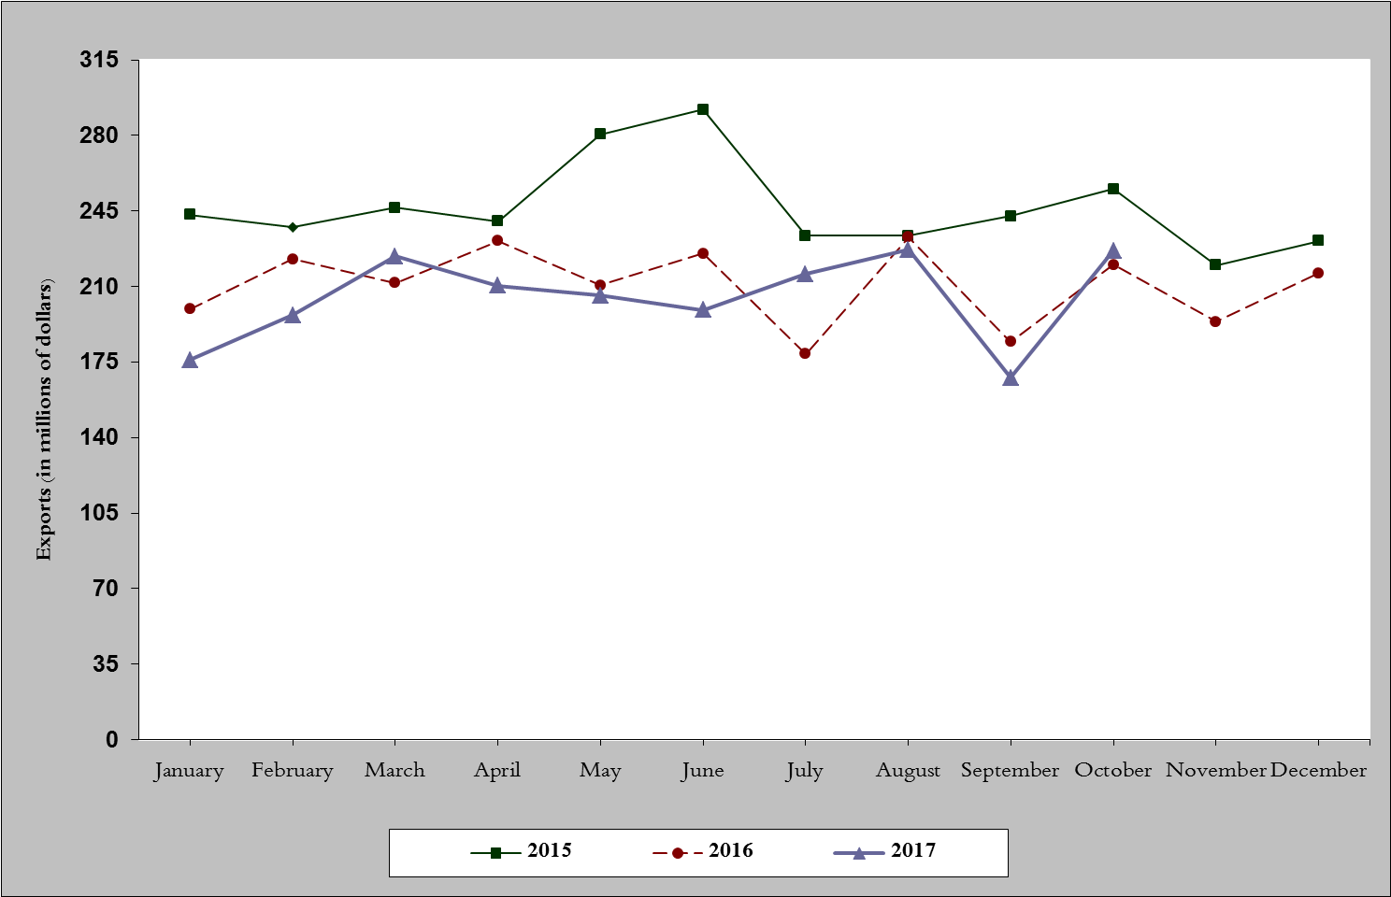
Chart 1: Industrial exports during years 2015-2016-2017
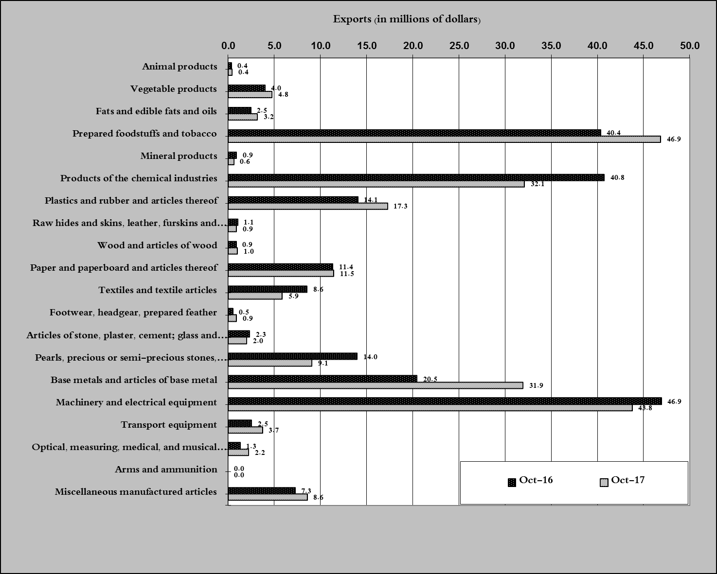
Chart 2: Comparison of industrial exports during October 2017 and October 2016

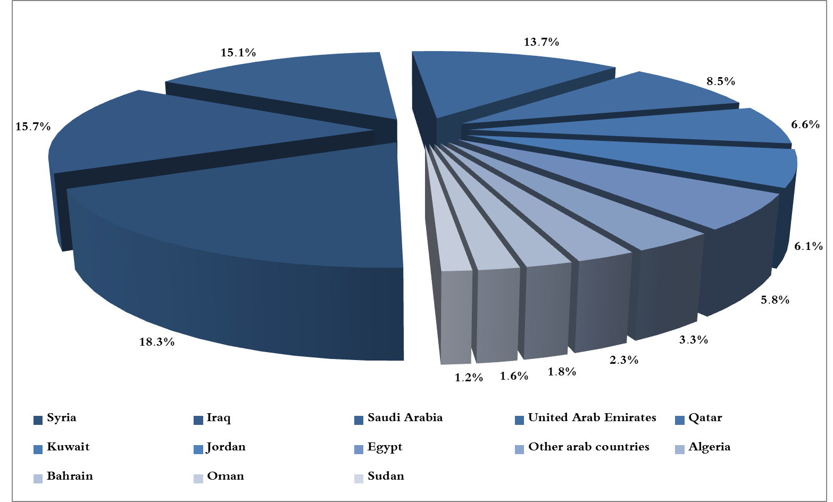
Chart 3: Distribution of industrial exports to Arab countries during October 2017
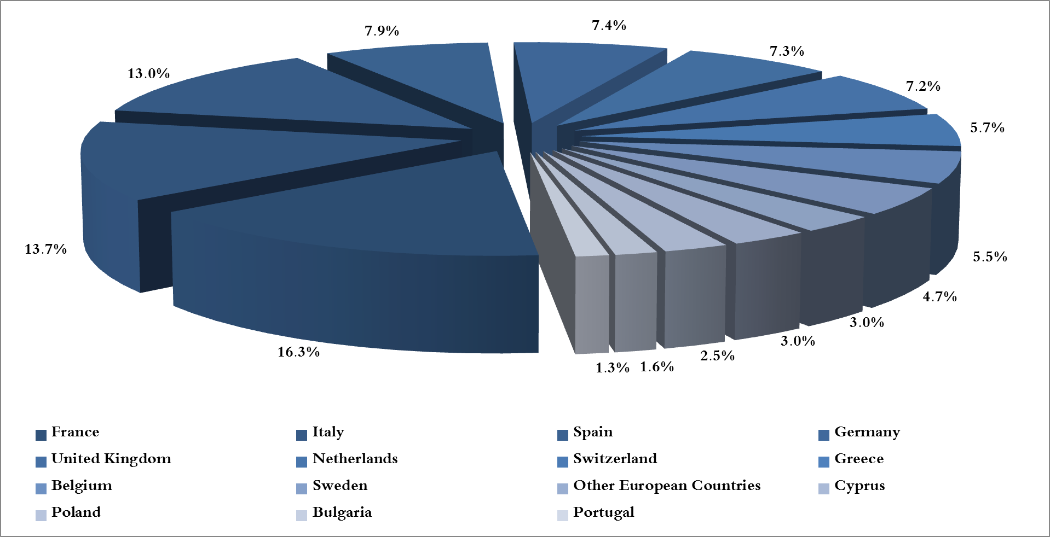
Chart 4: Distribution of industrial exports to European countries during October 2017

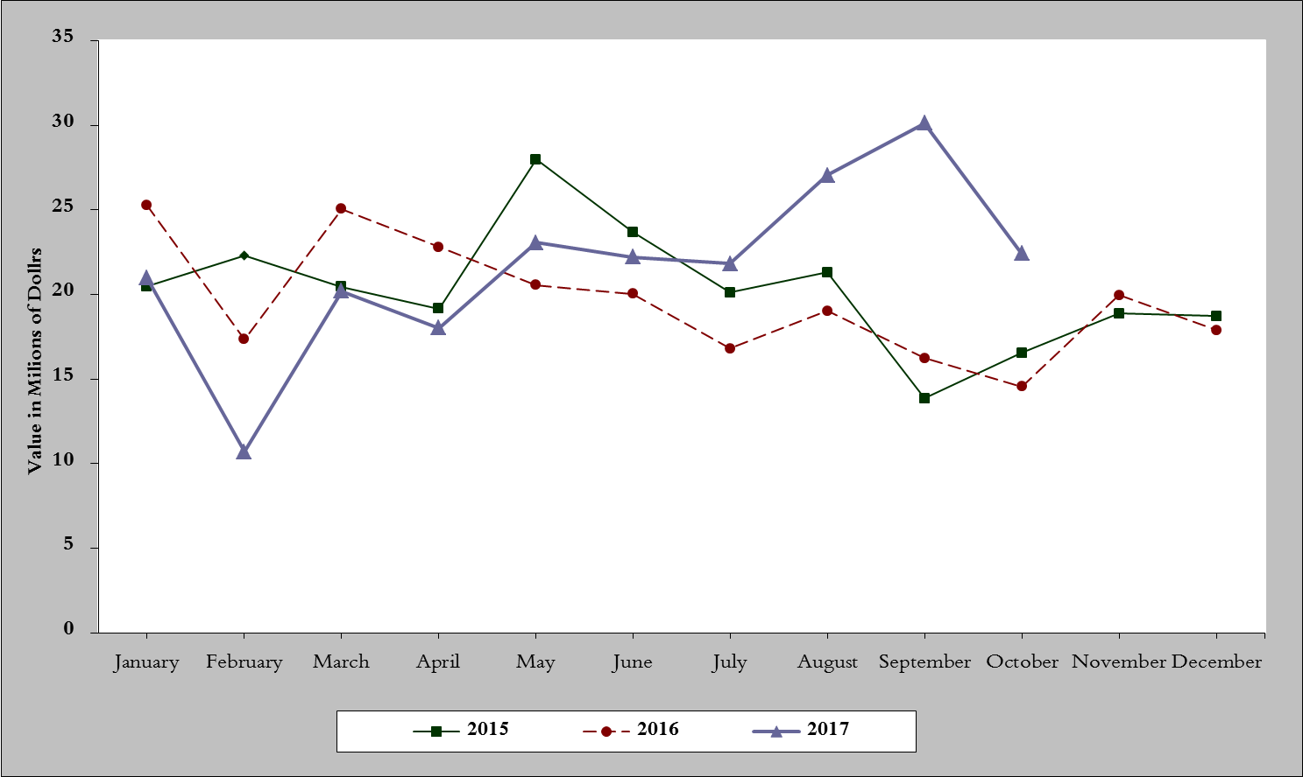
Chart 5: Imports of industrial machinery and equipment during years 2015-2016-2017
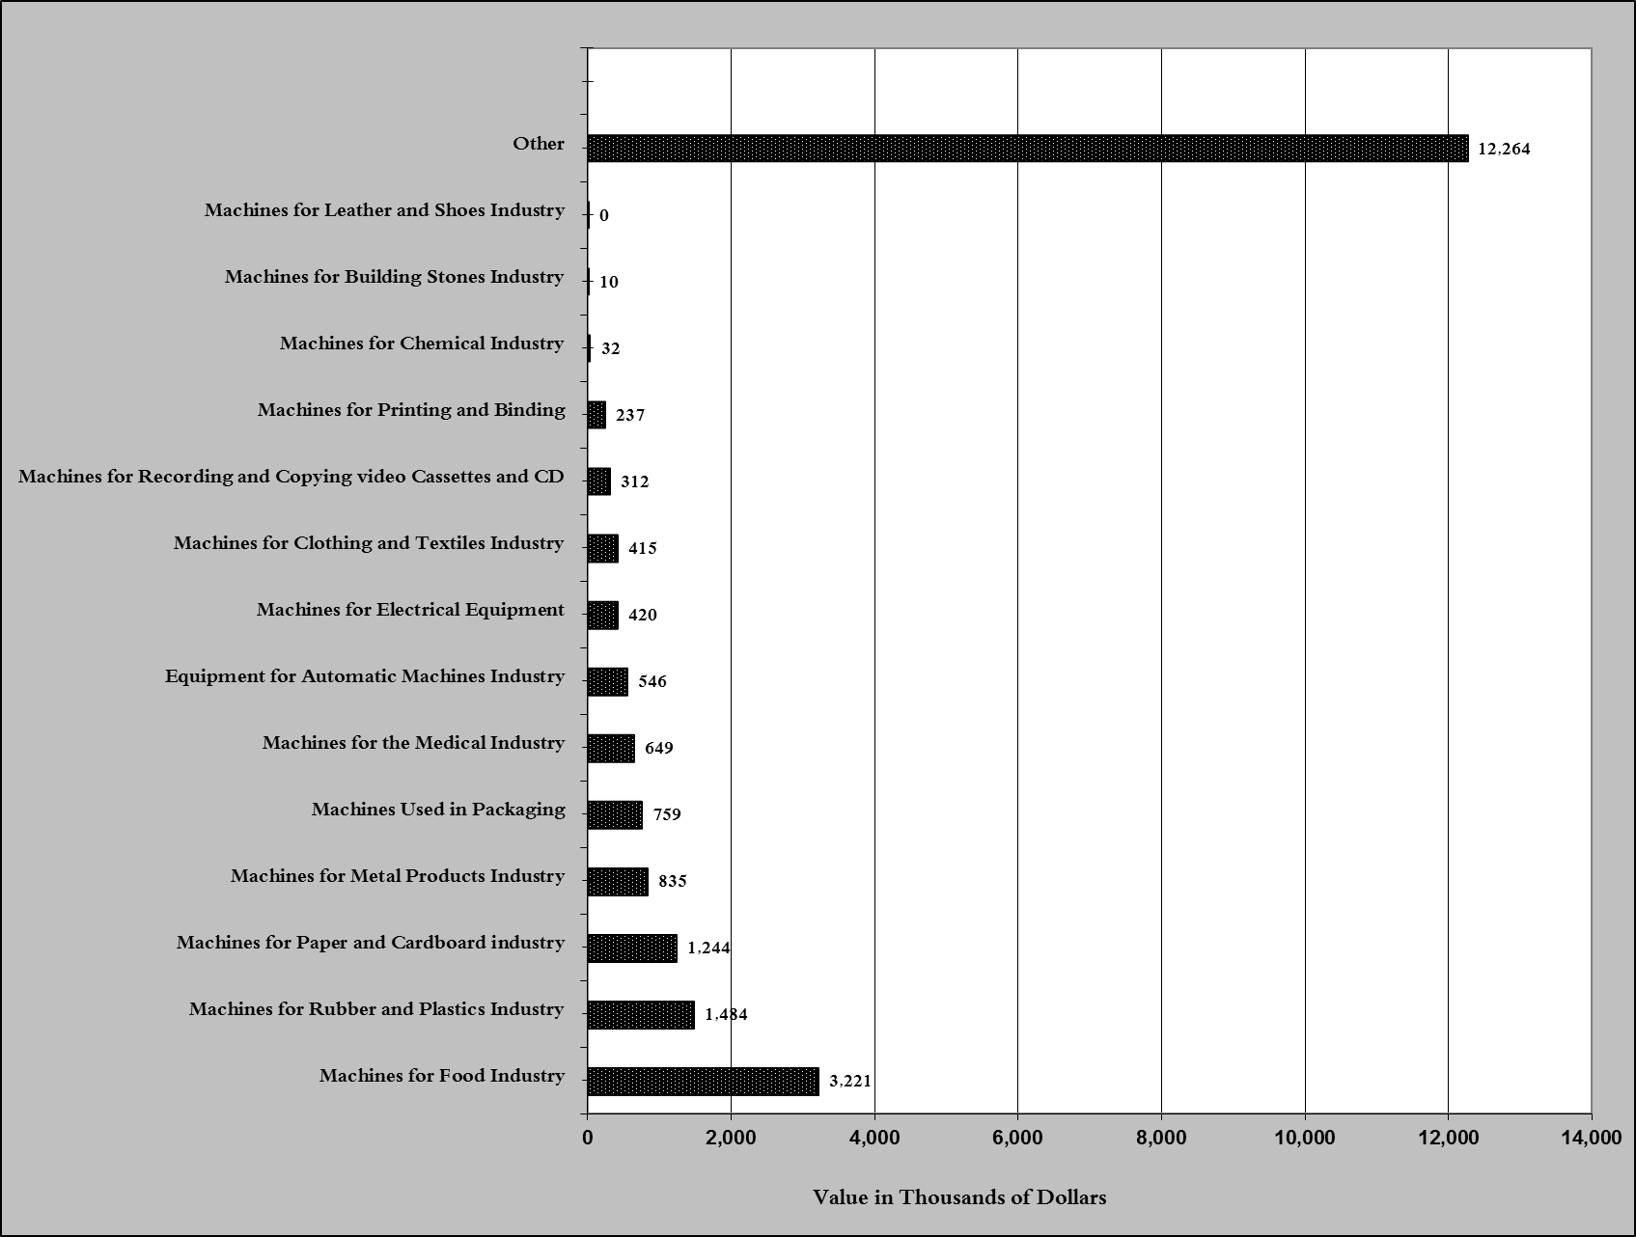
Chart 6: Imports of industrial equipment and machinery according to industrial activity during October 2017

Exports of unworked Diamonds, Silver and Gold Ingots reached this month a value of 19.6 million USD
The machineries and equipment are classified in this table according to the industrial sectors that are used in, while heading "other" includes machineries and equipment that can be used in various sectors.

